**Cross account AMI copy:**

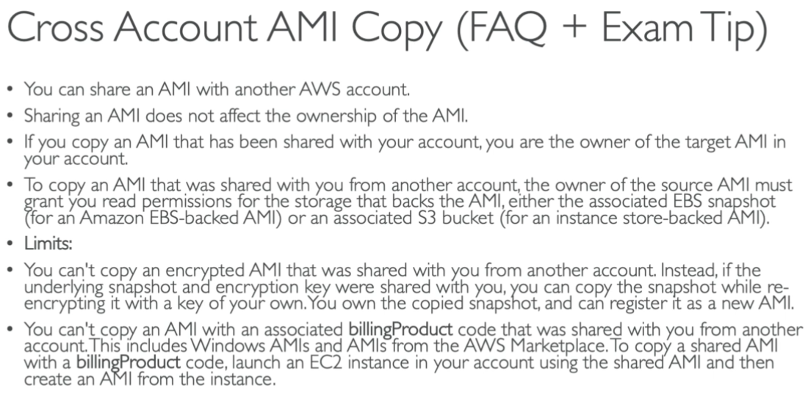

**Hands on:**

* Right click on the image. Select **“modify image permissions”** option.

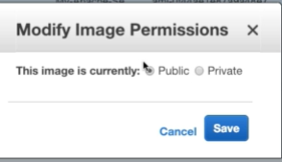

* You can make it public so that everyone can see it.

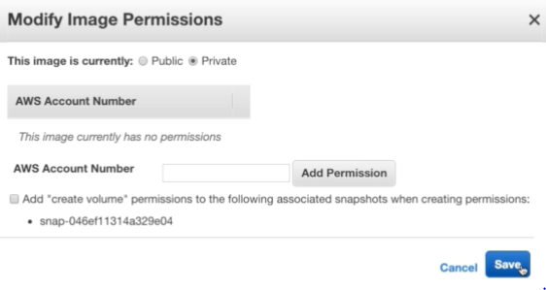

* Or we can make it private with the specific AWS account numbers.
* We can also add multiple accounts here.
* If we check **“create volume”** permissions, then the user can be able to create EBS volumes from that snapshot. If we don’t check that option, then they can’t.
* By default, the users can’t copy the AMIs which shared. But they can always create an instance from that AMI. Then they can create another AMI from that instance.